Ex.No:10

**DATABASE WITH VIEW, INDEX**

**AIM:**

To create view, index and sequence on the given relation.

1)Create a view with name ‘std_view’ using STUDENT table which holds the value of register number, name and DOB of student.

mysql> create view stu_view as select regno,name and dob from student;

Query OK, 0 rows affected (0.13 sec)

mysql> select* from stu_view;

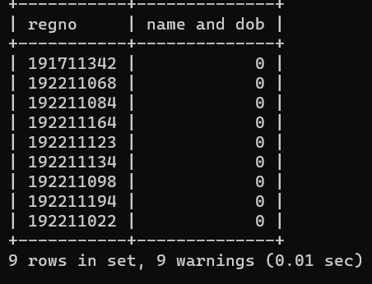

mysql> create index regno on student(regno);

Query OK, 0 rows affected (0.15 sec)

2)Create index1 for ‘salary’ attribute from employee1 relatiion and list the first name of the employees whose salary is above 145000 and explain the working principle of index and drop index

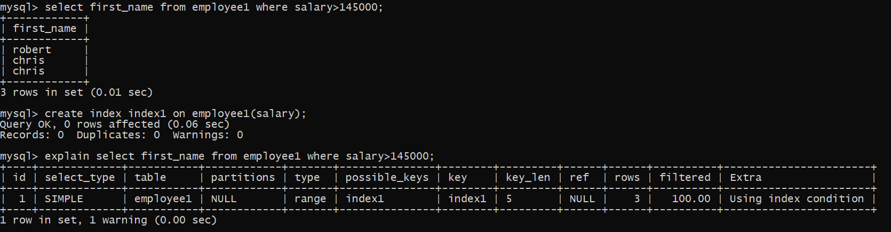

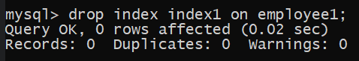

3)Create index1 for ‘employee_id’ attribute and display the first_name of the employee whose employee_id is 10 and explain the working principle of index1

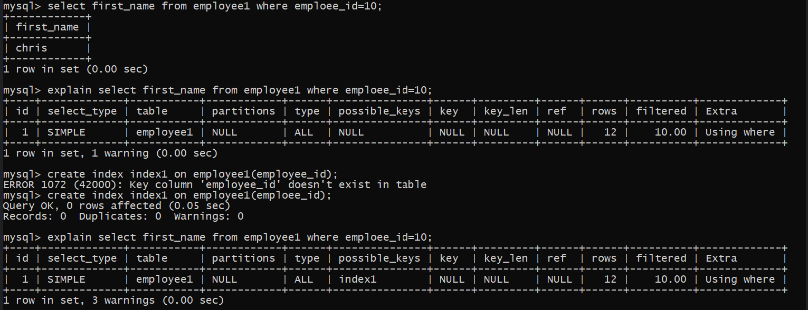

4) Populate register number using increment in DBMS_STUD table

Manually Populate Register Number

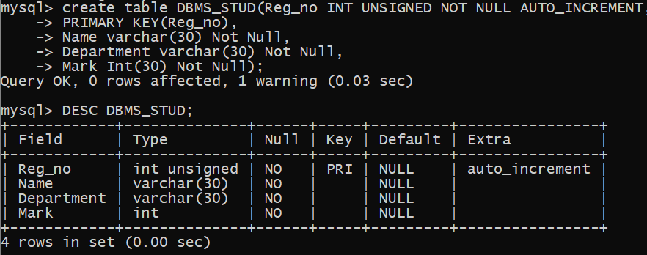

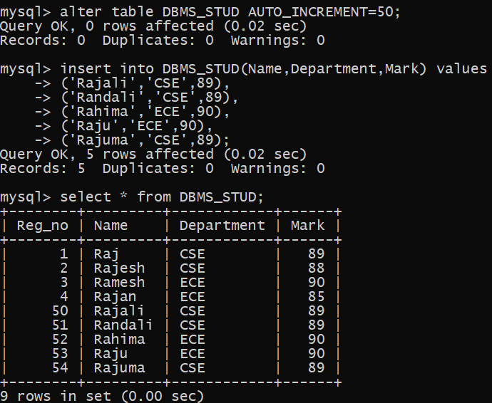

5) Drop the auto increment

